Regression Methods
- Elastic net (glmnet)
- Random forest (randomForest and rfPermute)
- SVM (e1071)

Incorporating Uncertainty in Ages
Training sample set
- ALL (all samples)
- CR3+ (samples with confidende rating >= 3)
- CR4+ (samples with confidende rating >= 4)

Sample weighting
- None
- Linear (CR/5)
- CRC (weights chosen by Sabre and Michael)
*Only used with elastic net and random forest

CpG site selection
- None (use all sites)
- Elastic net: build 100 replicate models with identical parameters, record how often each CpG site was included in the final model, select sites included in at least 50% of models
- Random forest: build 100 replicate models with identical parameters using rfPermute, record p-value of each site in each model, select sites that had p <= 0.05 in at least 50% of models

Site selection model parameters:
CpG subset | Regression method | Training sample set | Weighting scheme | Number of CpG sites selected
1 | Elastic net | ALL | none | 26
2 | Elastic net | ALL | linear | 36
3 | Elastic net | ALL | CRC | 32
4 | Elastic net | CR3+ | none | 31
5 | Elastic net | CR3+ | linear | 31
6 | Elastic net | CR3+ | CRC | 31
7 | Elastic net | CR4+ | none | 46
8 | Elastic net | CR4+ | linear | 44
9 | Elastic net | CR4+ | CRC | 44
10 | Random forest | ALL | none | 21
11 | Random forest | ALL | linear | 21
12 | Random forest | ALL | CRC | 19
13 | Random forest | CR3+ | none | 20
14 | Random forest | CR3+ | linear | 21
15 | Random forest | CR3+ | CRC | 21
16 | Random forest | CR4+ | none | 19
17 | Random forest | CR4+ | linear | 20
18 | Random forest | CR4+ | CRC | 20
RESULTS

Models with all sites included
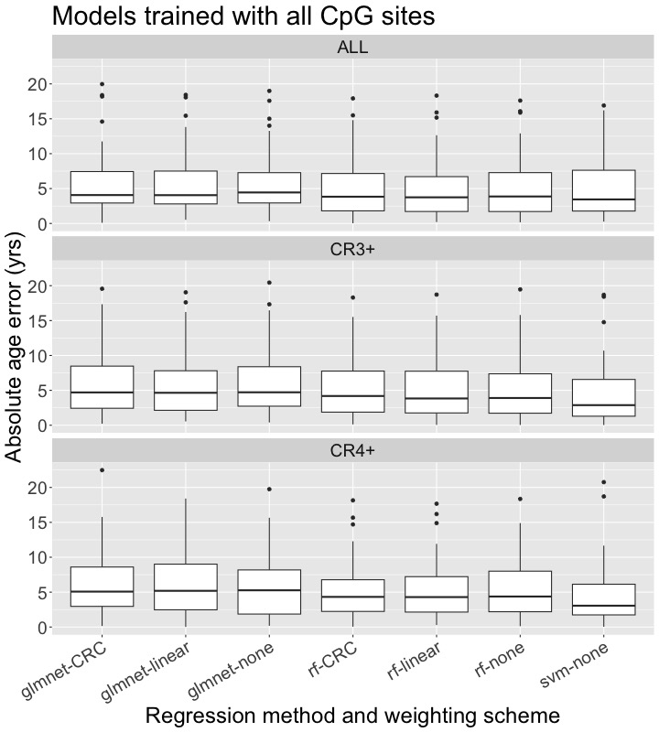
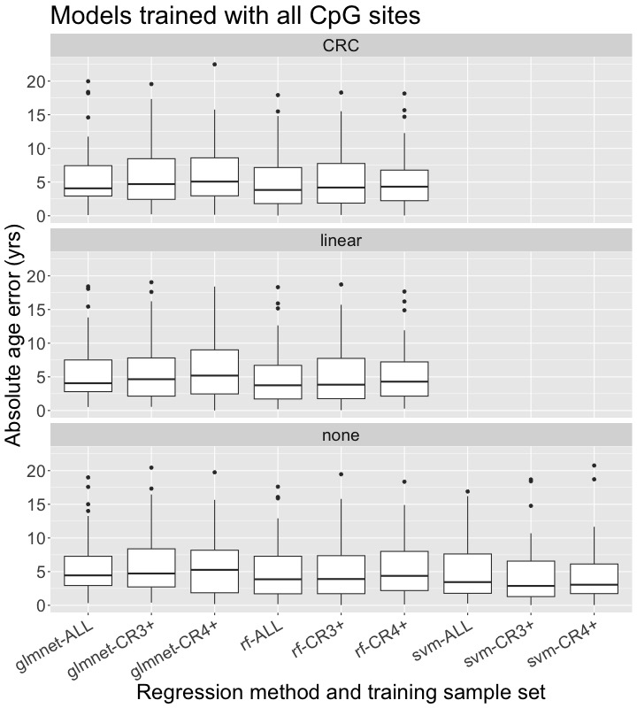

CpG Site Selection
